Question 1
This program should be designed and written by a team of students. Here are some
suggestions:
• One student should design function main , which will call the other functions in the
program. The remainder of the functions will be designed by other members of the
team.
• The requirements of the program should be analyzed so each student is given about
the same work load.
• The parameters and return types of each function should be decided in advance.
• The program can be implemented as a multi-file program, or all the functions can
be cut and pasted into the main file.
Here is the assignment: Write a program that can be used by a small theater to sell
tickets for performances. The theater’s auditorium has 15 rows of seats, with 30 seats
in each row. The program should display a screen that shows which seats are available
and which are taken. For example, the following screen shows a chart depicting each
seat in the theater. Seats that are taken are represented by an * symbol, and seats that
are available are represented by a # symbol:

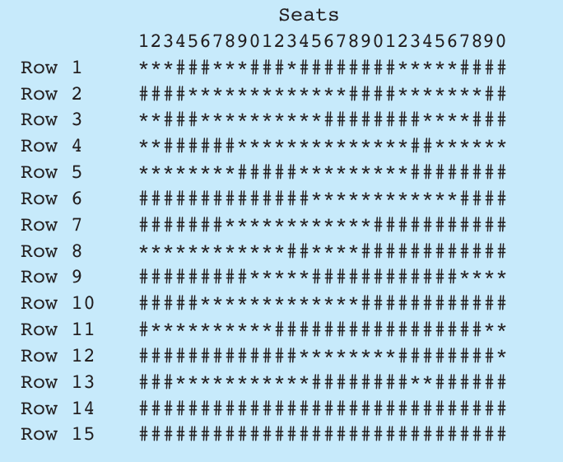
Here is a list of tasks this program must perform:
• When the program begins, it should ask the user to enter the seat prices for each row.
The prices can be stored in a separate array. (Alternatively, the prices may be read
from a file.)
• Once the prices are entered, the program should display a seating chart similar to
the one shown above. The user may enter the row and seat numbers for tickets being
sold. Every time a ticket or group of tickets is purchased, the program should display
the total ticket prices and update the seating chart.
• The program should keep a total of all ticket sales. The user should be given an
option of viewing this amount.
• The program should also give the user an option to see a list of how many seats
have been sold, how many seats are available in each row, and how many seats are
available in the entire auditorium.
Input Validation: When tickets are being sold, do not accept row or seat numbers that
do not exist. When someone requests a particular seat, the program should make sure
that seat is available before it is sold.

Question 2
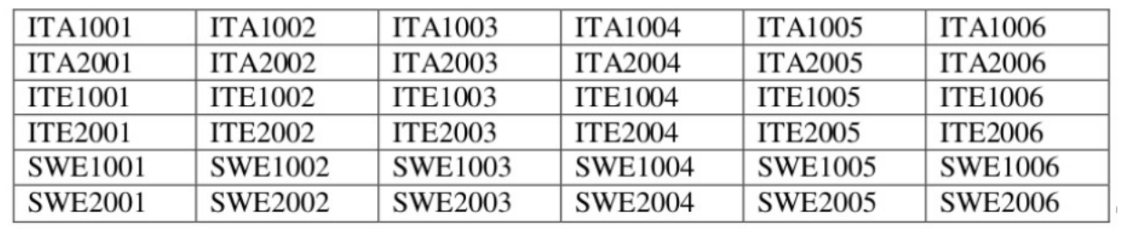
The table mentioned above contains the course codes of courses that are to be offered in the next
semester. A faculty can give 5 preferences from within the list for course allocation. Get the
preferences through command line arguments. If a faculty fails to give his/her preferences, then the
Time table committee may fill the preferences by choosing any 5 courses randomly from the list. If a faculty gives less than 5 preferences, the left out ones will be filled randomly. Write a program to
implement the same and print the 5 preferences at last.
[Hint: Generate 5 random numbers within the range 0-35 as there are a total of 36 courses in the
table. Use the generated random number to find out the row number and column number of the
table to choose the course. Example: if the generated number is 17, row number=17/6=2 and
column number=17%6=5. Therefore the course ITE1006 should be used for filling.]

Question 3
A small airline has just purchased a computer for its new automated reservations system. You’ve
been asked to develop the new system. You’re to write an application to assign seats on each flight
of the airline’s only plane (capacity: 10 seats). Your application should display the following
alternatives: Please type 1 for First Class and Please type 2 for Economy. If the user types 1, your
application should assign a seat in the first class section (seats 1–5). If the user types 2, your
application should assign a seat in the economy section (seats 6–10). Your application should then
display a boarding pass indicating the person’s seat number and whether it’s in the first-class or
economy section of the plane. Use a one-dimensional array of primitive type boolean to represent
the seating chart of the plane. Initialize all the elements of the array to false to indicate that all the
seats are empty. As each seat is assigned, set the corresponding element of the array to true to
indicate that the seat is no longer available.
Your application should never assign a seat that has already been assigned. When the economy
section is full, your application should ask the person if it’s acceptable to be placed in the first-class
section (and vice versa). If yes, make the appropriate seat assignment. If no, display the message
"Next flight leaves in 3 hours."

